
COLEGIO REPUBLICA DE COLOMBIA
SIGLO XXI
ENGLISH | NAME:_________________ | GRADE
ENGLISH | TEACHING AREA:  MILENA SUAREZ | DATE______________

MY FAMILY
- Rodea de color:
Amarillo= Mamá
Azul= Papá
Naranja= Hermana
Verde= Bebe
Rojo= Hermano






BODY PARTS
- Writeparts of thebody.

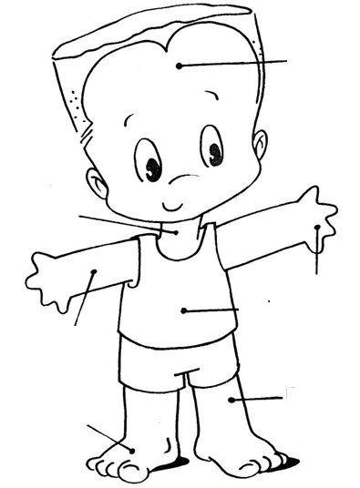

NUMBERS

- l wrirte in englishthefollowingnumbers

10=_____________________ 33=______________________

20=_____________________ 16=______________________

14=_____________________ 18=______________________

45=_____________________ 25=______________________

GEOMETRIC FIGURES
- yellow colors of the triangle.
colors blue circle
colors red square

THE TIME IN ENGLISH
- escribe la hora en ingles


 

